EWMA correlation: EURUSD and USDCAD
Method 06 / daily log returns / lambda = 0.94 / Alpari D1 full available history

Study setup
Logical pair: EURUSD , USDCAD
Broker symbols: EURUSD_i , USDCAD_i
Snapshot: 2026-11-03_majors_alpari_D1
Timeframe: D1
Matched return window: 1999-01-05 to 2026-11-02 (UTC bar dates)
Matched return count n: 7188
Dropped unfinished last bar dated 2026-11-03 UTC after a tick-volume check against the prior complete day.
Lambda: 0.94 (today weight 0.06)
Burn-in ignored in path summaries and chart: first 60 updates
Mean adjustment: each leg demeaned by its mean on the matched rows
Seeds: c_0 = v_x,0 = v_y,0 = 0
Complete matched rows (Excel): EURUSD-USDCAD_EWMA_D1.xlsx
Complete matched rows (HTML table): EURUSD-USDCAD_EWMA_D1_data.html

Method carried forward
EWMA correlation updates covariance and variances of mean-adjusted daily log returns of close, ln(close_t / close_t-1), with lambda = 0.94 (6% weight on today's product or square, 94% on yesterday's EWMA state). Quotes are not inverted. Each leg is demeaned by its mean on the matched rows; that mean uses the full sample, so the rho path is a full-sample description, not a live filter. Seeds start at zero. Path summaries and the chart ignore the first 60 updates so the zero seed has faded. The headline is rho on the last day. rho is symmetric under swap of the two symbols. A high |rho| does not prove cause, lead-lag, or a trading signal. Today's return sits inside today's rho, so the estimate can only inform a later decision. Same-sample Pearson r is a side check only.

Results
Latest EWMA rho: -0.616377
Post-burn-in path (n=7128): mean=-0.429907, median=-0.468194, min=-0.860639, max=0.530718, std=0.241228
Share of post-burn-in days with |rho| >= 0.4: 61.17%; |rho| >= 0.7: 11.25%
Same-sample Pearson r: -0.456626
Latest rho minus r: -0.159751

Conclusion
Over 7188 matched daily log-return rows for EURUSD and USDCAD (broker quote directions unchanged), latest EWMA rho with lambda=0.94 is -0.6164 (negative, moderate recent linear link in this sample). After a 60-day burn-in, path mean is -0.4299, std is 0.2412, and the range is [-0.8606, 0.5307]. Same-sample Pearson r is -0.4566 (latest rho minus r = -0.1598). This does not establish cause, lead-lag, or a lasting trading rule.

Charts
Daily closes

Daily log returns
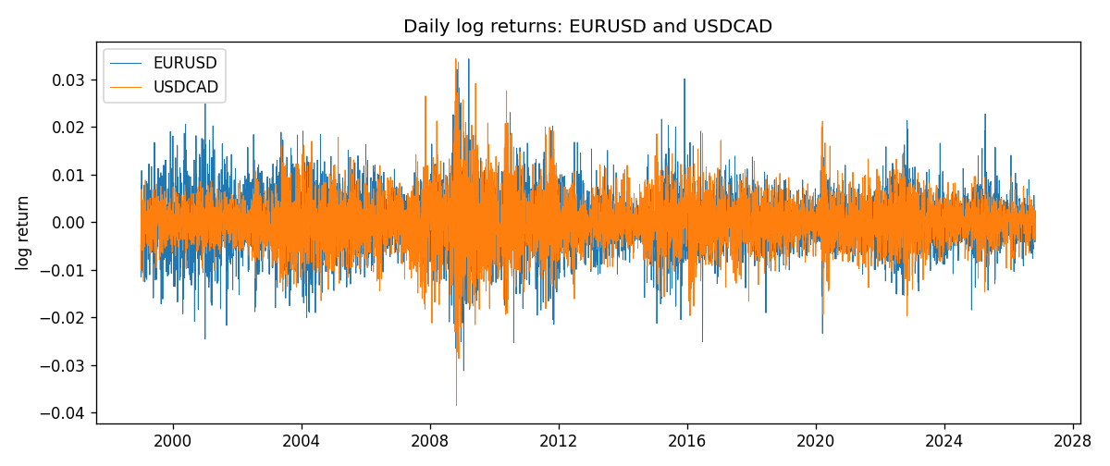
EWMA rho path with Pearson r reference
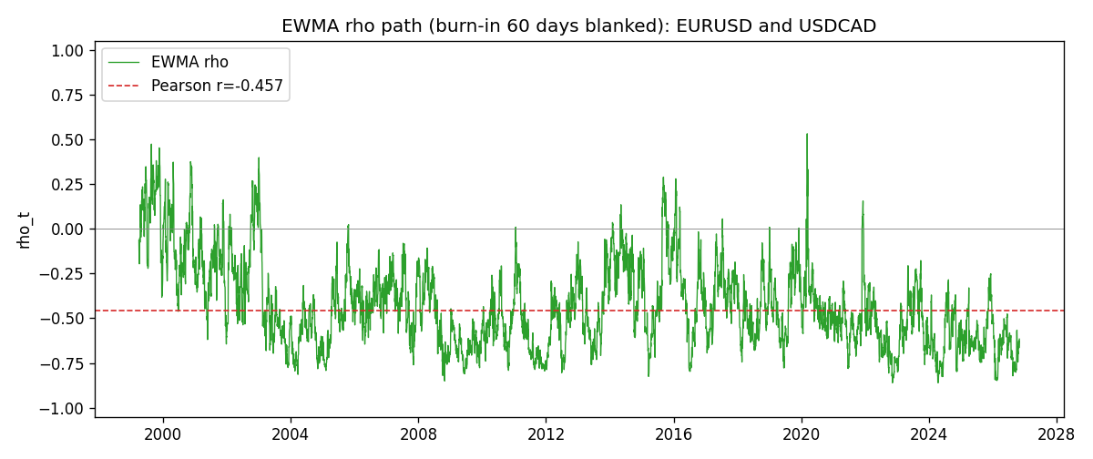

Data report
Every matched row that entered the EWMA recursion is stored in the sibling Excel workbook named EURUSD-USDCAD_EWMA_D1.xlsx. That file is the complete data archive for redrawing charts. Embedding all rows as a Word table is impractical at this length; the Word file holds the column list, column summaries, and the first and last 15 matched rows.
Columns: time, EURUSD_open, USDCAD_open, EURUSD_high, USDCAD_high, EURUSD_low, USDCAD_low, EURUSD_close, USDCAD_close, EURUSD_tick_volume, USDCAD_tick_volume, EURUSD_spread, USDCAD_spread, EURUSD_real_volume, USDCAD_real_volume, EURUSD_log_return, USDCAD_log_return, EURUSD_x_demeaned, USDCAD_y_demeaned, c_t, v_x, v_y, rho_t
Column summaries (matched calculation rows)
column | count | mean | std | min | 25% | 50% | 75% | max
EURUSD_open | 7188 | 1.1814345 | 0.15078289 | 0.8272 | 1.086195 | 1.16617 | 1.2939425 | 1.5995
USDCAD_open | 7188 | 1.2667783 | 0.16890181 | 0.9168 | 1.1183975 | 1.298465 | 1.37211 | 1.6183
EURUSD_high | 7188 | 1.1865652 | 0.15138546 | 0.8326 | 1.0902775 | 1.17128 | 1.2993025 | 1.6038
USDCAD_high | 7188 | 1.2716763 | 0.16885945 | 0.9336 | 1.12285 | 1.30387 | 1.37649 | 1.619
EURUSD_low | 7188 | 1.1764236 | 0.15010221 | 0.8227 | 1.0820675 | 1.16257 | 1.2883725 | 1.5865
USDCAD_low | 7188 | 1.26222 | 0.16893673 | 0.9056 | 1.114065 | 1.293535 | 1.367805 | 1.6102
EURUSD_close | 7188 | 1.181473 | 0.1507571 | 0.8267 | 1.0860725 | 1.166175 | 1.2939575 | 1.5997
USDCAD_close | 7188 | 1.2667932 | 0.16887388 | 0.916 | 1.118295 | 1.29844 | 1.372365 | 1.6137
EURUSD_tick_volume | 7188 | 103177.84 | 173518.96 | 218 | 9407.75 | 52764 | 99553.25 | 1471626
USDCAD_tick_volume | 7188 | 81016.727 | 147303.02 | 37 | 5545 | 40941.5 | 71627 | 1410818
EURUSD_spread | 7188 | 19.349471 | 16.556644 | 0 | 8 | 12 | 30 | 50
USDCAD_spread | 7188 | 23.444073 | 18.266035 | 0 | 9 | 17 | 40 | 60
EURUSD_real_volume | 7188 | 4.031926e+10 | 1.6689501e+11 | 0 | 0 | 0 | 0 | 3.6149665e+12
USDCAD_real_volume | 7188 | 1.8376704e+10 | 9.6688094e+10 | 0 | 0 | 0 | 0 | 2.5751613e+12
EURUSD_log_return | 7188 | -7.59e-06 | 0.00580128 | -0.03123819 | -0.0032472 | 0 | 0.00325412 | 0.03433183
USDCAD_log_return | 7188 | -1.518e-05 | 0.00514306 | -0.03859748 | -0.00283637 | 4.741e-05 | 0.00272353 | 0.03436319
EURUSD_x_demeaned | 7188 | 0 | 0.00580128 | -0.03123059 | -0.00323961 | 7.59e-06 | 0.00326171 | 0.03433942
USDCAD_y_demeaned | 7188 | 0 | 0.00514306 | -0.0385823 | -0.00282119 | 6.259e-05 | 0.00273871 | 0.03437837
c_t | 7188 | -1.361e-05 | 1.941e-05 | -0.00022702 | -1.625e-05 | -8.61e-06 | -4.5e-06 | 1.688e-05
v_x | 7188 | 3.363e-05 | 2.633e-05 | 1.4e-06 | 1.664e-05 | 2.746e-05 | 4.242e-05 | 0.00025676
v_y | 7188 | 2.643e-05 | 3.124e-05 | 3.69e-06 | 1.172e-05 | 1.8e-05 | 2.903e-05 | 0.00040857
rho_t | 7188 | -0.42438994 | 0.24890821 | -0.86063857 | -0.60883703 | -0.4659455 | -0.28439938 | 1
First 15 matched rows (selected columns)
time | EURUSD_close | USDCAD_close | EURUSD_log_return | USDCAD_log_return | EURUSD_x_demeaned | USDCAD_y_demeaned | c_t | v_x | v_y | rho_t
1999-01-05 | 1.1758 | 1.5123 | -0.0048360507 | -0.010131666 | -0.0048284583 | -0.010116482 | 2.9308207e-06 | 1.3988405e-06 | 6.1405928e-06 | 1
1999-01-06 | 1.1623 | 1.5118 | -0.011547966 | -0.0003306769 | -0.011540374 | -0.00031549352 | 2.9734263e-06 | 9.3057239e-06 | 5.7781294e-06 | 0.40549776
1999-01-07 | 1.1712 | 1.5141 | 0.0076280636 | 0.0015202092 | 0.007635656 | 0.0015353925 | 3.4984444e-06 | 1.2245575e-05 | 5.5728874e-06 | 0.42349204
1999-01-08 | 1.1585 | 1.511 | -0.010902799 | -0.0020495197 | -0.010895207 | -0.0020343364 | 4.6184087e-06 | 1.8633173e-05 | 5.4868256e-06 | 0.45676033
1999-01-11 | 1.1503 | 1.5057 | -0.007103287 | -0.0035137769 | -0.0070956946 | -0.0034985936 | 5.8308013e-06 | 2.0536115e-05 | 5.8920255e-06 | 0.53007435
1999-01-12 | 1.1555 | 1.5157 | 0.0045103728 | 0.0066194721 | 0.0045179652 | 0.0066346555 | 7.2794618e-06 | 2.0528669e-05 | 8.1796232e-06 | 0.56176183
1999-01-13 | 1.1681 | 1.5226 | 0.010845346 | 0.0045420214 | 0.010852939 | 0.0045572048 | 9.810238e-06 | 2.6364126e-05 | 8.9349327e-06 | 0.63918594
1999-01-14 | 1.1681 | 1.5332 | 0 | 0.0069376546 | 7.5924061e-06 | 0.006952838 | 9.224791e-06 | 2.4782281e-05 | 1.1299354e-05 | 0.5512633
1999-01-15 | 1.1563 | 1.5245 | -0.010153245 | -0.0056905671 | -0.010145653 | -0.0056753837 | 1.2126132e-05 | 2.9471401e-05 | 1.2553992e-05 | 0.63042145
1999-01-18 | 1.1605 | 1.526 | 0.0036256946 | 0.00098344542 | 0.003633287 | 0.00099862879 | 1.1616262e-05 | 2.8495163e-05 | 1.1860588e-05 | 0.63186999
1999-01-19 | 1.1603 | 1.5302 | -0.00017235436 | 0.002748513 | -0.00016476195 | 0.0027636963 | 1.0891965e-05 | 2.6787082e-05 | 1.1607234e-05 | 0.61770225
1999-01-20 | 1.1566 | 1.5211 | -0.0031939256 | -0.0059646885 | -0.0031863332 | -0.0059495051 | 1.1375874e-05 | 2.578902e-05 | 1.3034596e-05 | 0.62046681
1999-01-21 | 1.1601 | 1.5146 | 0.0030215416 | -0.0042823796 | 0.003029134 | -0.0042671963 | 9.9177668e-06 | 2.4792218e-05 | 1.3345058e-05 | 0.54525036
1999-01-22 | 1.1587 | 1.5184 | -0.0012075213 | 0.0025057712 | -0.0011999289 | 0.0025209546 | 9.1412029e-06 | 2.3391075e-05 | 1.2925667e-05 | 0.52571669
1999-01-25 | 1.1552 | 1.5197 | -0.0030251979 | 0.00085579808 | -0.0030176055 | 0.00087098146 | 8.435034e-06 | 2.2533967e-05 | 1.2195644e-05 | 0.50882172
Last 15 matched rows (selected columns)
time | EURUSD_close | USDCAD_close | EURUSD_log_return | USDCAD_log_return | EURUSD_x_demeaned | USDCAD_y_demeaned | c_t | v_x | v_y | rho_t
2026-10-13 | 1.11965 | 1.4214 | 0.0037402957 | -0.0046395653 | 0.0037478881 | -0.0046243819 | -6.1503112e-06 | 1.0566967e-05 | 7.2194537e-06 | -0.70415741
2026-10-14 | 1.11545 | 1.42356 | -0.0037582255 | 0.0015184751 | -0.0037506331 | 0.0015336584 | -6.126424e-06 | 1.0776984e-05 | 6.927413e-06 | -0.70904353
2026-10-15 | 1.12172 | 1.41843 | 0.0056053107 | -0.0036101503 | 0.0056129031 | -0.003594967 | -6.9695306e-06 | 1.2020646e-05 | 7.2871954e-06 | -0.7446624
2026-10-16 | 1.12371 | 1.41357 | 0.0017724895 | -0.0034322068 | 0.0017800819 | -0.0034170234 | -6.9163136e-06 | 1.1489528e-05 | 7.5505266e-06 | -0.74256583
2026-10-19 | 1.12086 | 1.41091 | -0.0025394633 | -0.0018835331 | -0.0025318709 | -0.0018683497 | -6.2175096e-06 | 1.1184779e-05 | 7.3069389e-06 | -0.68775701
2026-10-20 | 1.12354 | 1.40569 | 0.0023881672 | -0.0037066008 | 0.0023957596 | -0.0036914175 | -6.375084e-06 | 1.0858072e-05 | 7.6861163e-06 | -0.69784035
2026-10-21 | 1.12318 | 1.4045 | -0.00032046717 | -0.00084691787 | -0.00031287477 | -0.0008317345 | -5.9769652e-06 | 1.0212461e-05 | 7.2664563e-06 | -0.69383178
2026-10-22 | 1.12139 | 1.40081 | -0.0015949606 | -0.0026307268 | -0.0015873682 | -0.0026155434 | -5.3692375e-06 | 9.7508977e-06 | 7.240933e-06 | -0.63898851
2026-10-23 | 1.11989 | 1.40085 | -0.001338521 | 2.85545e-05 | -0.0013309286 | 4.3737878e-05 | -5.0505759e-06 | 9.2721261e-06 | 6.8065918e-06 | -0.63575003
2026-10-26 | 1.11735 | 1.40093 | -0.0022706559 | 5.7106554e-05 | -0.0022630635 | 7.2289932e-05 | -4.7573572e-06 | 9.0230859e-06 | 6.3985098e-06 | -0.62610734
2026-10-27 | 1.11272 | 1.40449 | -0.004152342 | 0.0025379458 | -0.0041447496 | 0.0025531291 | -5.1068406e-06 | 9.5124377e-06 | 6.4057073e-06 | -0.65421854
2026-10-28 | 1.1152 | 1.39911 | 0.0022262927 | -0.0038379274 | 0.0022338851 | -0.003822744 | -5.3128044e-06 | 9.241106e-06 | 6.8981672e-06 | -0.66541869
2026-10-29 | 1.11772 | 1.39895 | 0.0022571351 | -0.00011436495 | 0.0022647275 | -9.9181574e-05 | -5.0075133e-06 | 8.9943791e-06 | 6.4848674e-06 | -0.65567099
2026-10-30 | 1.11644 | 1.39751 | -0.0011458446 | -0.0010298736 | -0.0011382522 | -0.0010146902 | -4.6377641e-06 | 8.5324534e-06 | 6.1575511e-06 | -0.63983454
2026-11-02 | 1.11881 | 1.39837 | 0.002120569 | 0.00061519094 | 0.0021281614 | 0.00063037432 | -4.279006e-06 | 8.2922504e-06 | 5.8119403e-06 | -0.61637656

